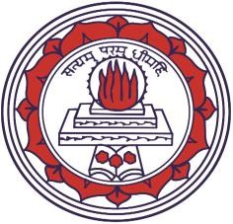
Shrimathi Devkunvar Nanalal Bhatt Vaishnav College for Women (Aided Stream)
Affiliated to University of Madras, Re-accredited with A+ Grade by NAAC, Chromepet, Chennai 600044.

Volume II VAISH E-BULLETIN September – November 2019

TCS ORIENTATION

Tata Consultancy Services along with our college organized an academically inspiring programme which was held on September 4, 2019. The programme was taken over by Mr. Stephen, an employee of TCS. The programme was an interactive session which emphasized on creating an interface between education and the workspace. He gave a detailed account of the working of industries and markets.

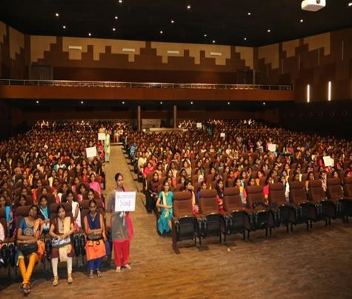
He explained the benefits of the course through which the students are exposed to the additional information regarding the sectors of their interest and, the special privilege by gaining reduced training period as well as access to specialized panel of interviewers in a prolific scale. The entire session was student centric. At the end of the session, the students were made aware of better means of getting placed in companies.

TEACHERS DAY CELEBERATION
The Teachers day was celebrated in the campus premises on September 5, 2019. Teachers were invited by students who were filled with great zeal and enthusiasm.
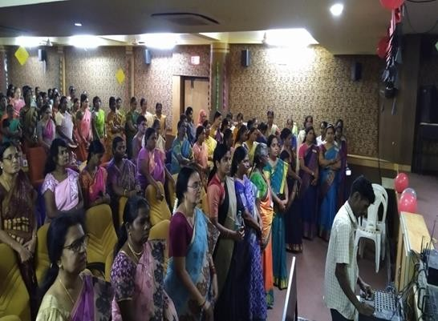
Our honourable Principal Dr. R. Geetha delivered a speech on the importance of the role of teachers in the life of a student. An Audio Visual was played for the teachers. Union members organized various games for teachers. Students performed cultural programmes to entertain the teachers. Hostel students gave a special performance for teachers.
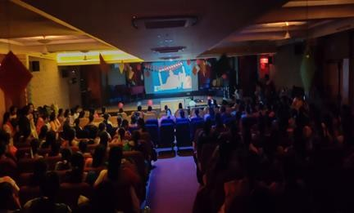
The teaching faculty gave their feedback appreciating the efforts of the students for making the gala celebration a memorable one.

MADHULIKA

Madhulika 2019 was organized by the UG Department of Plant Biology and Plant Biotechnology on 4th and 5th September 2019. The events were ‘Vegetable Carving’, ‘War on Waste’, ‘Pot Pourri’ and ‘Miss Madhulika’. Students from other departments participated actively with enthusiasm and zeal and made the event a fun filled one.
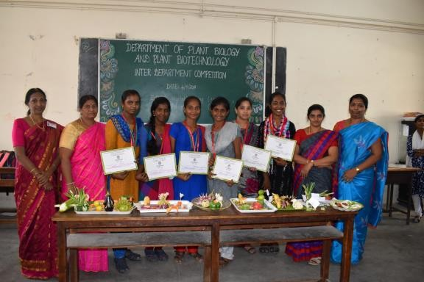

SANSKRIT ASSOSSIATION DAY
The Bhagavad Gita -“The Song of Divine” is the most precious gift from God for the salvation of mankind. Few shlokas from the Gita are recited on every Friday in the Sarvodaya prayer.
On September 9, 2019, Samkruta Ratna Dr. S. Ramaratnam, Vice Chancellor, Sri Jagadguru Kripaulu University, Cuttack, spoke about the ‘Relevance of Sanskrit in the Present Day Scenario’. He related all the day to day topics with Sanskrit literature. He mentioned many literary works which was very informative and inspirational to the students. The students presented a set of questions to the Chief Guest and he answered all the questions fulfilling the curious minds of the students. He was awarded with a token of appreciation by the Principal. With that there were also presentations and vocals for entertainment purposes. Students brought many laurels to the college by winning many prizes in various
competitions held throughout the year within and outside the college.
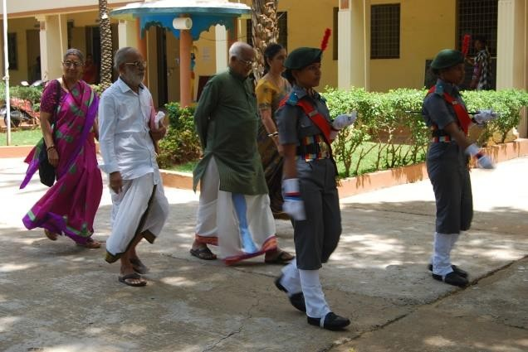
JAL SANRAKSHAN ABHIYAN – AN AWARENESS CAMPAIGN ON WATER CONSERVATION

The Hindi Department conducted literary competitions in Hindi at Inter Collegiate level on 12th Sep 2019. As a part this event, ‘JAL SANRAKSHAN ABHIYAN,’
an awareness campaign on water conservation was also organised.
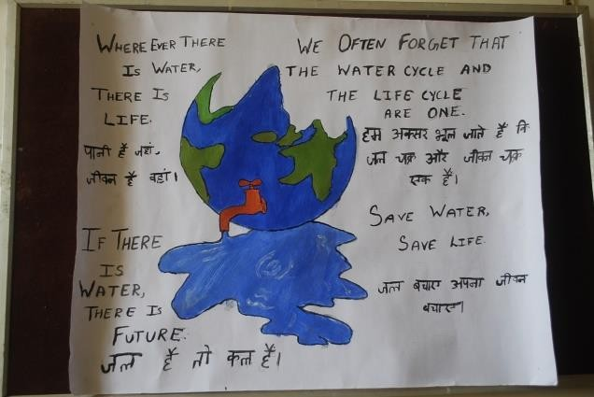
Students from various colleges of Chennai city took active part in this awareness campaign and rendered their support. Students were given a platform to express their views and innovative ideas regarding conservation of water and its resources. Students came up with plethora of ideas on Conservation of water. As a part of this campaign the students were encouraged to write awareness slogans on JAL SANRAKSHAN in Hindi. Best slogans and innovative ideas to save water rendered by the students were appreciated and were awarded trophies by the College. The programme came to an end with oath taking to save water.

MATHRIOR

The Mathematics association, “MATHRIOR” was conducted on 13th September 2019. Three interdepartmental events were conducted and those were Quiz, Paper Presentation, Potpourri. Students from other departments actively participated in the ibid mentioned competitions and unleashed their talents.

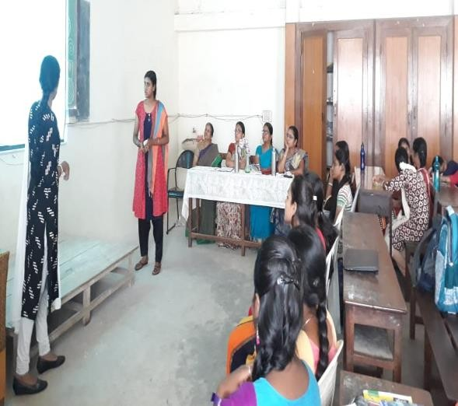

ONAM CELEBRATIONS

Onam celebration was held on September 14, 2019. The programme commenced at 11:00am in the mini auditorium. Our honourable Vice Principals Dr. P. Beena (Day) and Dr. S. Seethalakshmi (Evening) conducted the Pooja. Students organised the event in Malayalam. The students embellished the entrance of the mini auditorium with a poo kolam (Flower Carpet). An Audio visual was played regarding the significance of Onam. Students performed traditional dance and various other cultural activities.

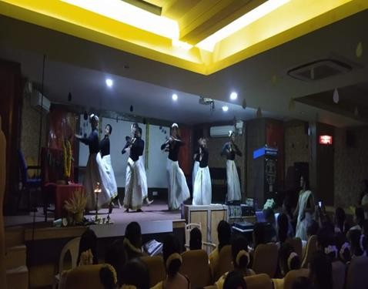

THE QUANTUM PLATORS

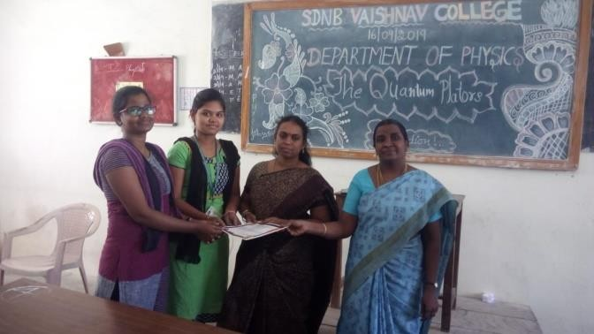
The Department of Physics organised its annual interdepartmental competition, “The Quantum Plators” on 16th September, 2019. The Judges for the day’s events were Dr. P. Beena Anil, Assistant Professor, Vice Principal (Day) SDNB, Vaishnav College for Women from the Department of English and Dr. T. Vijayalakshmi, Assistant professor, Department of Maths. The events conducted were Minute 2 Minute (quiz), Treasure hunt, Palm painting and Sci-Fi writing.

E-INFORMATIK
The empowering inter-departmental event, e-informatik 2019, was conducted by the Department of Computer Science on the 17th September 2019 to identify and glorify talents and promote a sense of sisterhood among the students of various departments.
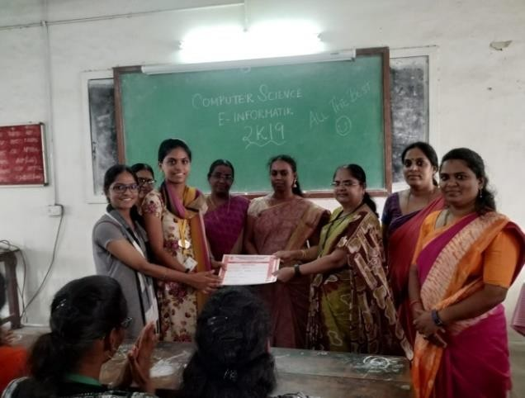

Students from other departments voraciously participated in the Tic Tac Toe, Quiz, E-waste events unleashing their knowledge in technology and their talent in creatively expressing it. Dr. Hemala and Dr.Shanthi from department of Mathematics graced the event Tic Tac Toe by aptly judging the talents on display and encouraging the participants to work towards improvising their knowledge. Mrs. Rajeswari and Dr. Kavitha from physics department were the judges of E- Waste. The Principal Dr. Geetha graced the Quiz event and distributed the prize.
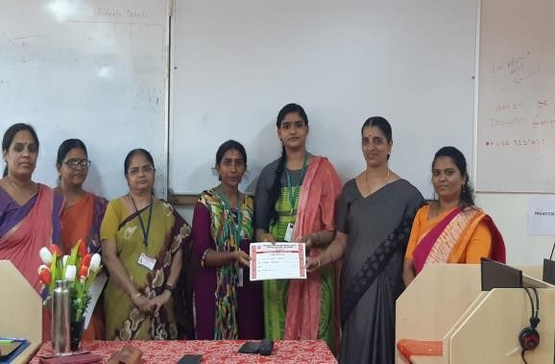
The combined efforts of the organizers, participants and judges made the event a spectacular success.

GANDHI JAYANTHI CELEBRATION

Gandhi Jayanthi celebration was held at the college auditorium on October 1, 2019. The function commenced at 11.30 am. The Chief Guest was Arathu Srinivasan, Vijay TV fame and a motivational speaker. The programme was presided over by the Principal, Dr. R. Geetha and the Vice Principals of both, aided and self- supporting stream. The celebrations began with the college prayer. Mr. Arathu Srinivasan spoke about online safety, women’s career safety and greatly insisted on social values. An Audio Visual based on the life of Mahatma Gandhi was played. The students greatly exhibited their talents through various cultural events. The programme was concluded with the National Anthem at 1.30 pm.
HINDI INTER DEPARTMENTAL COMPETITIONS
In an effort to bring out hidden talents of the students and to quench their thirst for art and language, Department of Hindi organised Inter Departmental level competitions in Hindi on October 1, 2019. The events conducted were ‘Agar Mein Aisa Hota’, ‘Ras Navras’ and ‘Vaad Vivaad’.
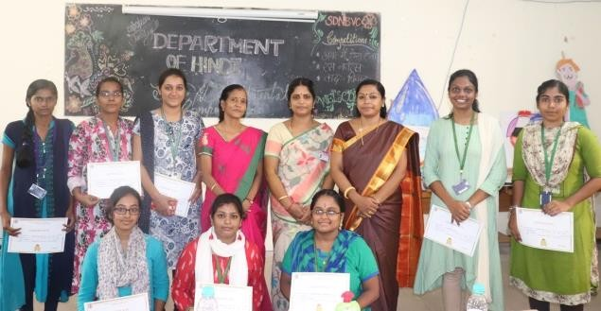
SANSKRIT - INTERDEPARTMENT LEVEL COMPETITIONS

The Sanskrit Department conducted three events as a part of Inter Departmental Competitions for the year 2019-2020 on 03rd October 2019. ‘Heads Up’, ‘I Am Susruta’ and ‘Catch the Match’ were the competitions held. The Judges were Dr.P. Ezhil Nachiar, Mrs. Hema, Mrs. P. Amrithashri, Ms. R. Lakshmi, and Dr. P. Beena. Students from various departments participated in these competitions enthusiastically and exhibited their talents.

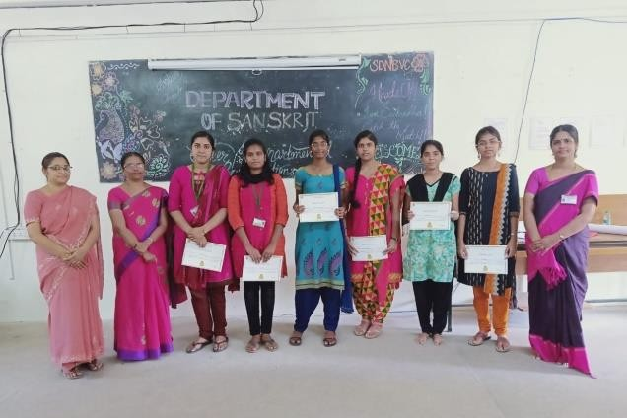

NATIONAL SEMINAR ON MATHEMATICAL ANALYSIS AND ITS APPLICATIONS

National Seminar on Mathematical Analysis and Applications was conducted by the Department of Mathematics on 9th October 2019. Nearly 250 students participated in this seminar. Also 10 City Colleges participated in the seminar. There were four Chief Guests. Dr. Francis Raj, Assistant Professor of Mathematics from Ramanujan School of Mathematical Sciences. He gave ideas on cracking entrance exams like CSIR, NBHM, GATE. His seminar was on continuity of a function at a point which he explained both theoretically and graphically.

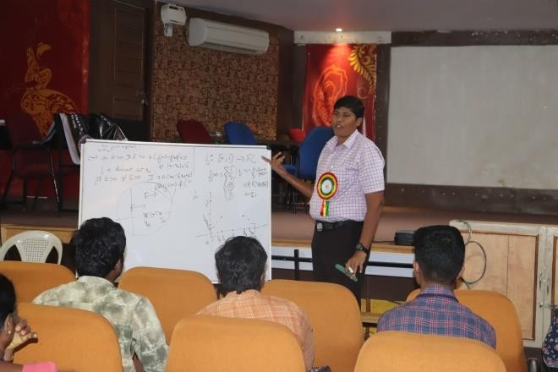
The second Chief Guest was Mr. Raveendra Pratab. He delivered a talk on Algebra and discussed many problems of various concepts in Algebra.

Dr.T.Praveen demonstrated the applications of the MATLAB. He explained about various functions and windows in Matlab and matrix operations.
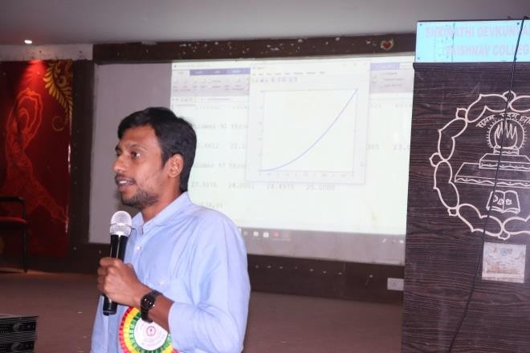
Dr. K. Kalaivani discussed many problems in various concepts in Complex Analysis.

All the above sessions motivated the participants to explore ideas in solving problems on Real Analysis, Algebra, Complex analysis to face NET, SLET, CSIR Exams.
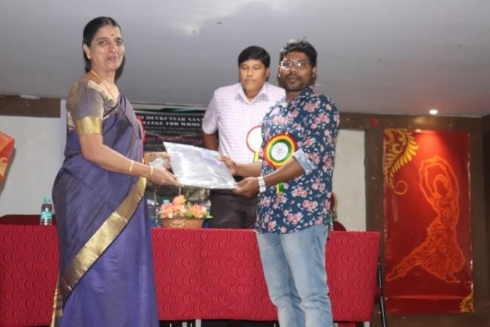

FACULTY DEVELOPMENT PROGRAMME - STATISTICS DEPARTMENT

The Faculty Development Programme was conducted by GITAA Pvt. Ltd. based on the topic “Predictive Analysis Using Python” on 23rd and 24th October 2019 which helps to know about basics of Python Programming. This was organized by the Department of Statistics. This programme proved very helpful for the faculty members.

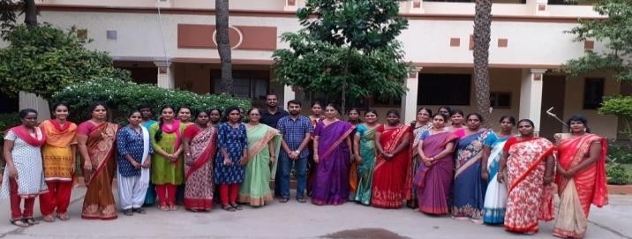
INFORMATION TECHNOLOGY
ON
LECTURE
GUEST
The Statistics Association activities for the academic year 2019-20 began with an Invited talk on “A rapid shift from industrial revolution to information technology: Where do you want to fit in?” by Dr. G.K. Balasubramani on September 6, 2019. His talk was on the importance of application of Data science in Industries.

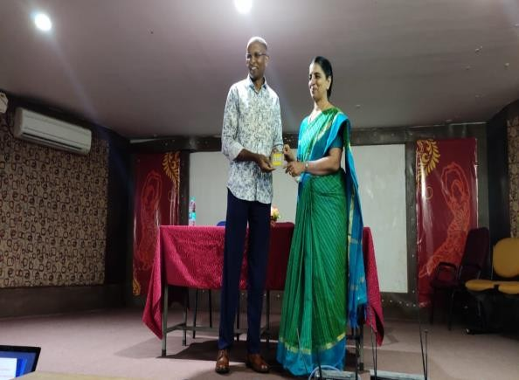

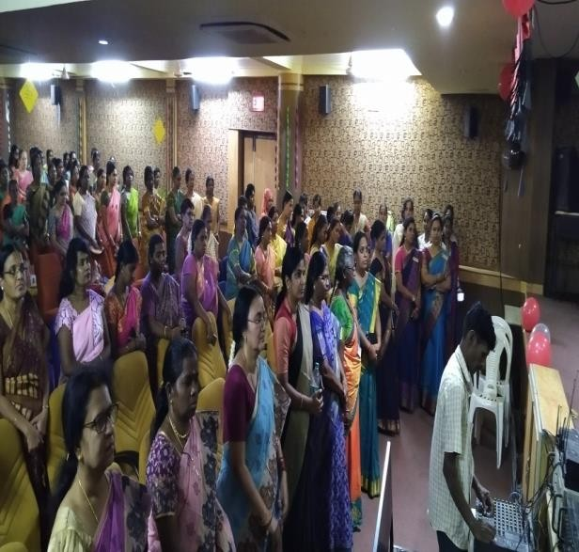
Hostel students gave a special performance for the teachers. The teaching faculties gave their feedback appreciating the efforts of the students in making the celebration a memorable one.

ODIN’S LITERATI

The PG Department of English inaugurated its Literary Association ‘Odin’s Literati’ on September 12, 2019 with a Guest Lecture on ‘English Studies Now: Texts and Contexts’ delivered by Dr. Supala Pandiarajan, Assistant Professor, Department of English, University of Madras.
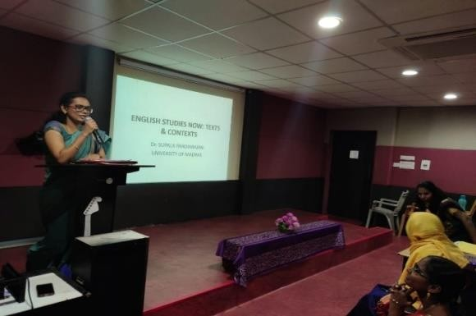
Dr. Supala Pandiarajan enlightened the students on the emerging trends and areas of study in English literature. The insightful lecture was followed by a question and answer session which helped the students get better understanding and valid resources.

DATA ANALYSIS USING EXCEL SPSS
The Department of M. Com (A&F) conducted a Workshop on “DATA ANALYSIS USING EXCEL & SPSS”
was conducted to impart Computer Literacy to the students of M. Com on September 17, 2019. They have shown their acute interest in learning the subject.

MIND SPARKLE: GENERAL QUIZ

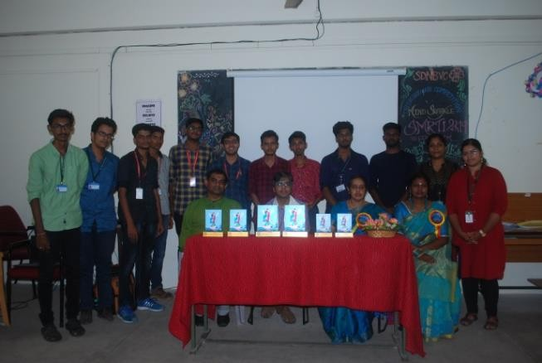

An Inter-Collegiate Quiz Competition was held on September 19, 2019, as a part of SMRTI 2K19. The event was conducted by Mr. Vikram Rajan and Mr. Ramachandran (avid quizzers and professional quiz masters). The competition began around 11:30 am and ended at 1:30 pm. A total of 16 teams from various colleges participated in the preliminary round with two participants per team, out of which 6 teams qualified for the finals.

HEART CHAMP

The “Heart Champ” workshop organized by the Department of Home Science on September 18, 2019, was appertaining to, a small, intricate organ, one which works non-stop and pumps life with its every beat, the heart. The facilitators for the workshop were, Dr. Priya Chockalingam, Director ; Vaishnav Natrajan, Chief
Physiotherapist and S. Tharani, Chief Dietician from the Cardiac Wellness Institute. As the famous saying goes, “Prevention is better than cure,” the subject matter for every session were based on ways by which CVD can be prevented and also about ways to become a champion of heart health. Heart Champ thus addressed the multifaceted aspects of ensuring optimum heart health.
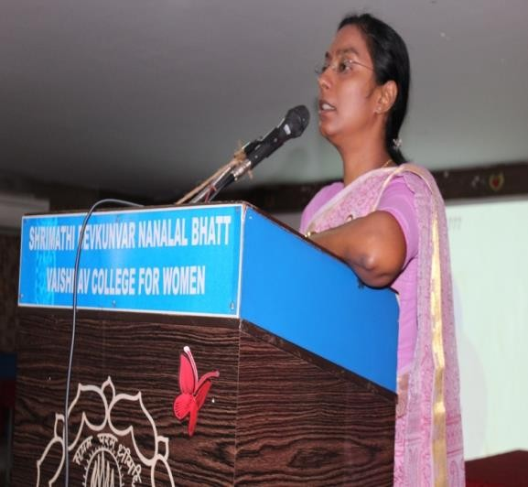

STRATEGIES OF SOCIAL MEDIA MARKETING
The Department of B. Com ISM conducted a Talk on Strategies of Social Media Marketing which was delivered by Mr. Raj Joseph, Director at Big Bytes on September 24, 2019. Students were taught how to use Face Book as a marketing tool during this session.
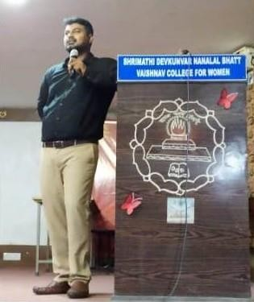

AWARENESS & EMPLOYMENT OPPORTUNITIES IN BANKING SECTOR
The Department of B.Com ISM also conducted a Talk on “Awareness & Employment Opportunities in Banking Sector” along with the Department of B.Com Banking Insurance and Management, which was delivered by Mr.
D.N. Bharat Padmanabhan on September 27, 2019. The session was very informative to students.
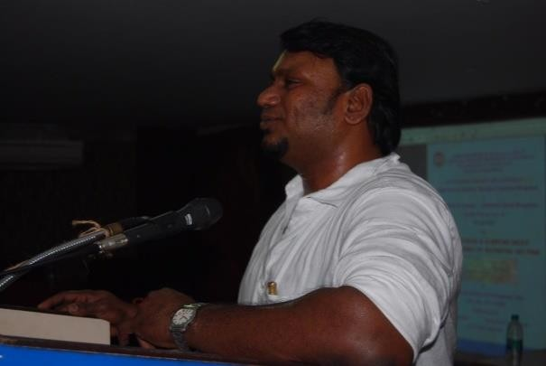

WORKSHOP ON “ELECTROPHORESIS”
A Workshop was organized by the PG Department of Plant Biology and Plant Biotechnology on September 30, 2019. The Resource Person was Dr. SARADA, Associate Professor, Department of Biotechnology, School of Bioengineering, SRM Institute of Science and Technology. In the Workshop, Isolation of DNA, RNA, Demonstration of PCR, Agarose Gel Electrophoresis of DNA and RNA, SDS- PAGE of Proteins were demonstrated and students had a hands on experience on these various techniques which were very useful for the students in their projects and also help them in procurement of job in
various scientific and other industrial areas.
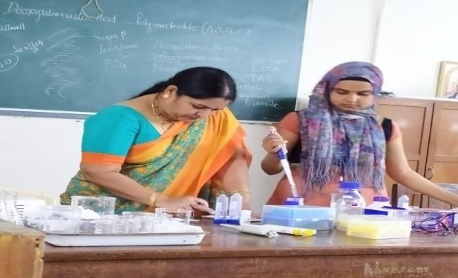

DEPARTMENT OF HINDI (EVE)

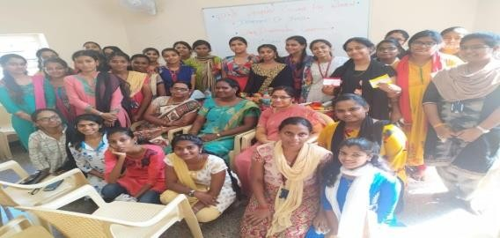
The Department of Hindi conducted its Inter-Departmental Competitions on October 3, 2019. The various competitions conducted were Ras Navaras, Loud Speaker, Vaad Vivad (Block and tackle). The events attracted many enthusiastic participants who took part actively.

FOOD CARNIVAL

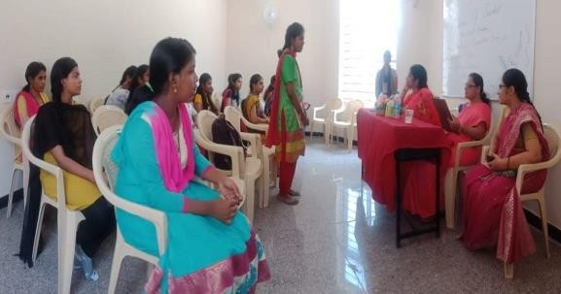
The PG department of Social Work organized Charity Fest 2k19 – “Kindness is magic” event (Inter-Departmental Competitions) on October 4, 2019 for a noble cause. The ultimate aim of the programme was to raise funds and contribute the same to the needy people (beneficiaries).

The programme was inaugurated with zeal by Mr. Silas Wesley, Food Vlogger and our beloved Principal Dr. R. Geetha. Mr. Silas Wesley addressed the gathering motivating them how to move on simultaneously with our profession as well as with passion. The Chief Guest and Principal visited the stalls and initiated with their contribution.

There were about 50 stalls exhibited by the college students, 6 stalls from outside vendors and NGOs. Nearly 2000 students from both the streams contributed and participated enthusiastically for this charity based event. Mr. Deva (Art Director) and Mrs. Priya (Makeup Artist) were the Chief Guests for the valedictory function.
I prize was bagged by B. Com General (Eve) and II prize was bagged by B.Sc. NFSMD. Certificates were also distributed to the students who participated enthusiastically for this charitable cause.

SANSKRIT COMPETITIONS

The Inter-Departmental Competitions were held on October 9, 2019 by the Department of Sanskrit (Evening). The various competitions conducted were Shloka Recitation, Pot Pourri and Treasure Hunt. Students participated actively in large numbers.

TAX PLANNING FOR INDIVIDUALS

The Research department of Commerce organized a workshop on “Tax Planning for Individuals” on 11th October 2019. Dr. Vengadamani, Director Amity Business School Chennai, was the Chief Guest for the workshop. The students were interactive during the entire session and the resource person rewarded the students who vivaciously responded to the questions that were posed for them.
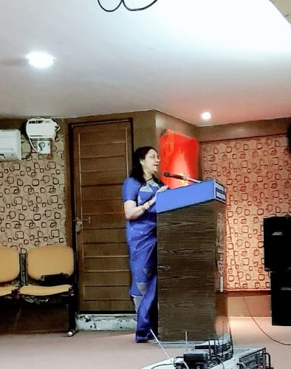

INTERNATIONAL FINANCIAL REPORTING STANDARDS (IFRS)

The Research department of Commerce organized a faculty development programme on “International Financial Reporting Standards (IFRS)” for the Commerce faculty members in collaboration with Amity Business School Chennai on 22nd and 23rd October 2019. Mr. C. S. Udayakumar was the resource person. The programme was beneficial for the faculty members.

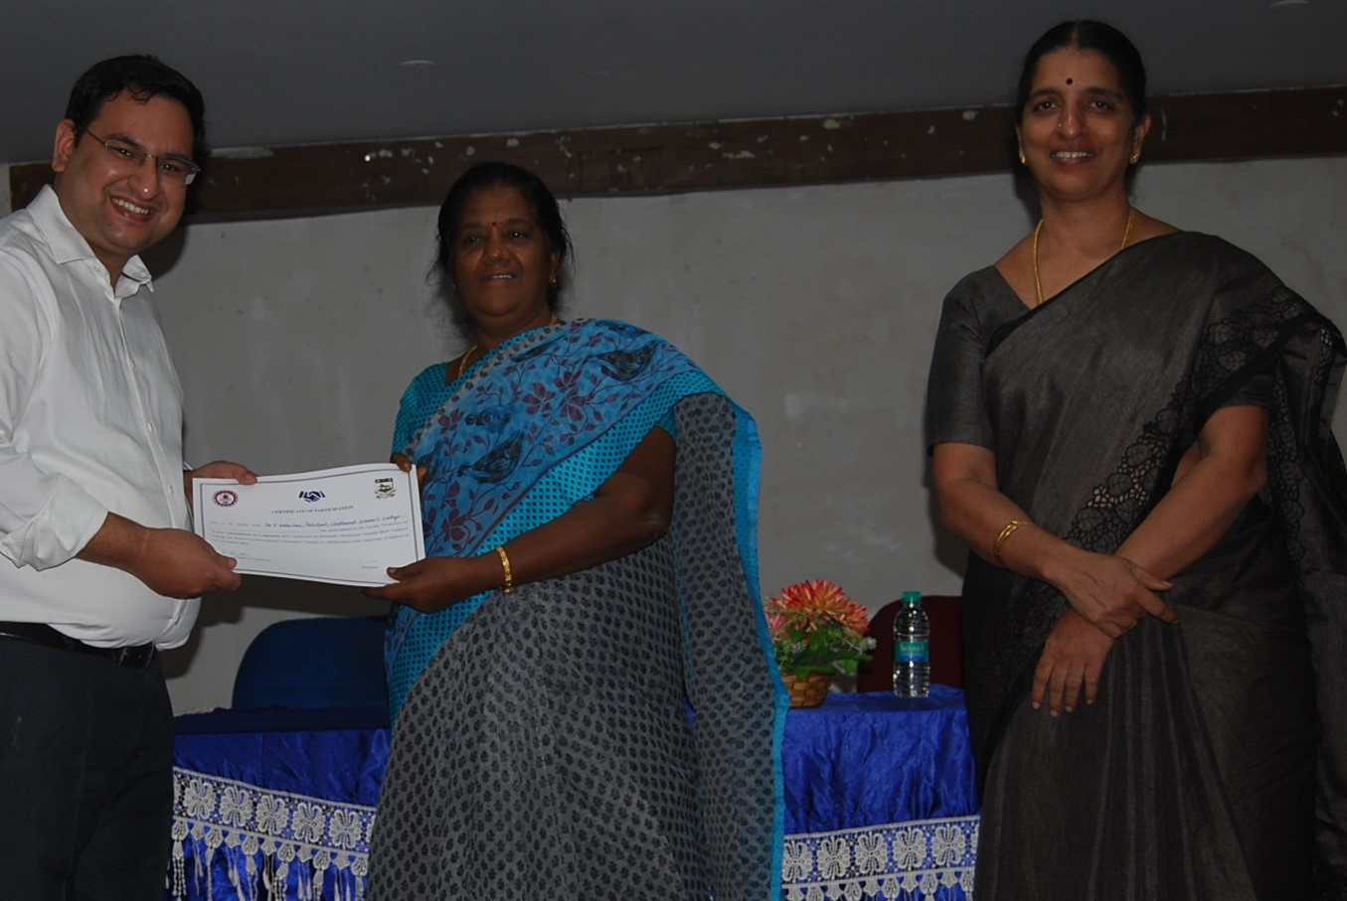

DRAFTING OF AUDIT REPORT AS PER CARO GUIDELINES

On 24th October 2019 the Research Department of Commerce organized a Faculty Development Programme on “Drafting of Audit Report as per CARO Guidelines” for the Commerce faculty members. Mr. C. A. Sivakanth, Manager Manohar Chowdary Associates Chennai, was the Chief Guest for the programme. 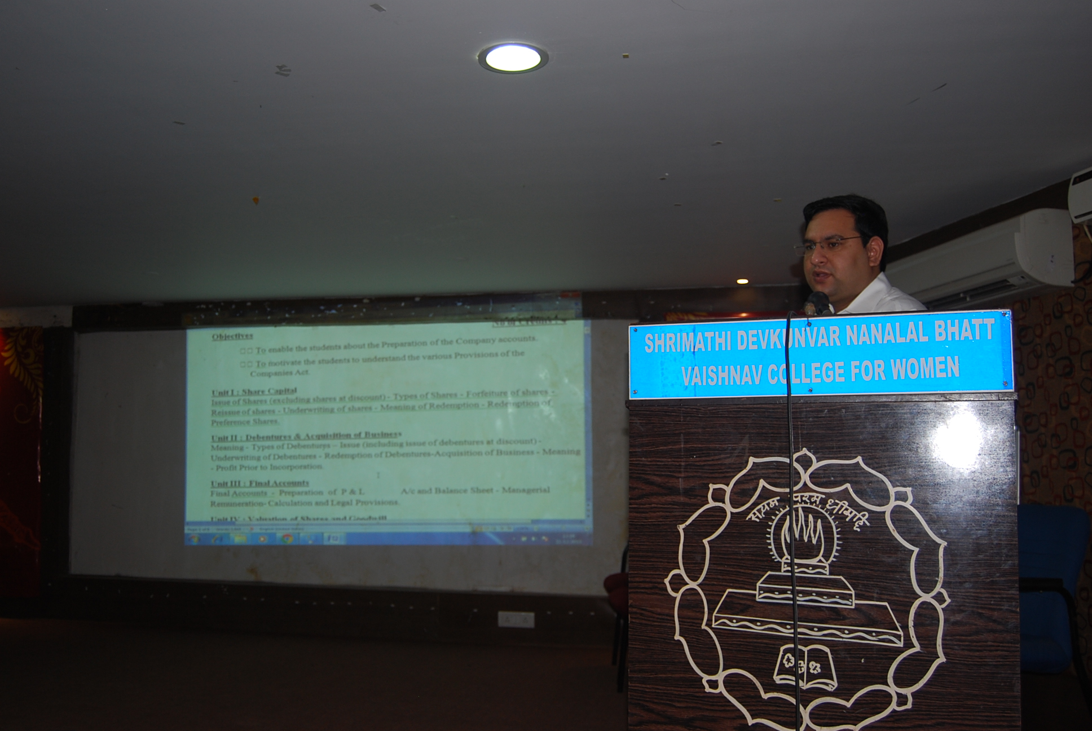

EDITOR IN CHIEF
Dr.R. Geetha, Principal

FACULTY EDITORS
Ms. G. Thilakavathy, Assistant Professor, Department of English

Mrs. L. Divyabharathi, Assistant Professor,
Department of English

Mrs. S. Susan, Assistant Professor, Department of English

STUDENT EDITORS
Priya Ayilam Chidambaran, III B.A. English

D. Pavithra, III B.Sc. Statistics

K. Hema Suriyaa, II B.Sc. Physics

Bhargavi, I M.A. English

Farzana Begum K, I M.A. English

