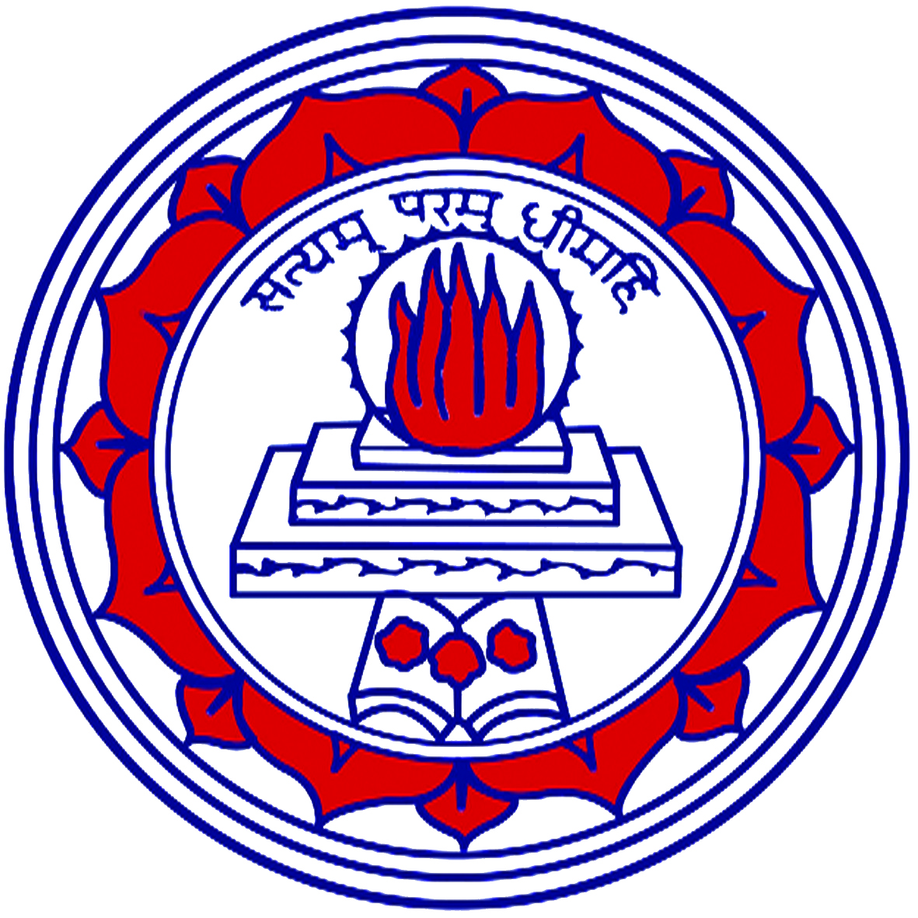
Shrimathi Devkunvar Nanalal Bhatt Vaishnav
College for Women (Aided Stream)
Affiliated to University of Madras, Re-accredited with A⁺ Grade by NAAC,
Chromepet, Chennai – 600044
  - Volume III VAISH E-BULLETIN December 2019-January 2020
STUDENTS’ UNION 2019-20 (DAY)
JALADHI FOUNDATION
Jaladhi Foundation, a Non-Governmental organisation conducted a wonderful awareness session on 12th December 2019. The session was inaugurated by the honourable Chief Guest, Chairman of Jaladhi Foundation Dr. Jaladhi Uma Shankar. The privileged Guests of Honour were Dr. Sreekala, Dr. Tamilselvi, Dr. T. Sujatha Venkatesh, Dr. T.N. Vijayashree, and Dr. D. Antoinette Mary Nithya. The Chief Guest delivered an inspirational speech. He encouraged women to live their life in a meaningful and authentic way. Dr. Sreekala explained about the preconception health and care. She also insisted that every woman should take rubella vaccination for preventing birth defects. Dr. Tamilselvi explained about the important facts of menstrual hygiene. Dr. T. Sujatha, MBBS, shared few words on importance of nutrition to prevent birth defects. She gave a few healthy diet plans. Dr. T.N. Vijayashree explained about the causes and treatments of uterus cancer. Dr. D. Antoinette Mary Nithya drew comparison of the percentage of women with breast cancer in India and USA. Students had a good learning experience by the end of the session.
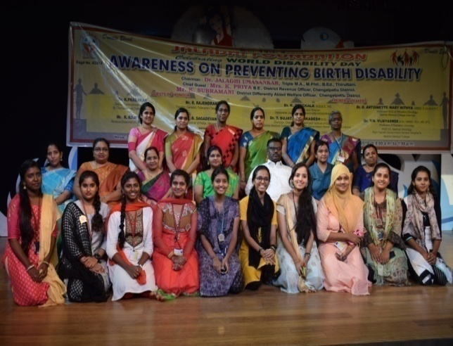
12.12.2019- KAVALAN SOS APP LAUNCH
Awareness about KAVALAN SOS App by Tamil Nadu Police was held on 12th December, 2019. Tamil Nadu police Dr. K. Prabhakaran, Deputy Commissioner of Police, Law and Order, St. Thomas Mount and Mr. K. Sahadevan, Assistant Commissioner of Police, Selaiyur, created awareness about the KAVALAN SOS App designed especially for women safety. 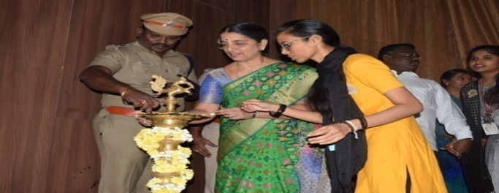
Dr. K. Prabhakaran demonstrated the working of the application. He asked the students to install the app in their mobile phones so as to alert the police in case of emergency. The session proved to be very useful for the students.
STUDENTS FORUM 2019 VAISH QUEST
The Students Forum- “VAISH QUEST” was inaugurated on 12th December 2019, by Deputy Commissioner of Police Prabakaran, Dr. R. Geetha, Principal and Dr. P. Beena, Vice Principal. Vaish Quest is a platform, for the students to display their hidden talents. The event was conducted on 16th December 2019. Students unleashed their skills like Dance, Drama, Poster Making, Story Telling, Story Writing, Poetry Writing and many more skills based on the theme “VALUES OF MODERN YOUNG GENERATION”. The judge panel consisted of Association Secretaries of various departments. The students found this as a golden opportunity to exhibit their talents. Appreciation Certificates were awarded for the best 5 performances.
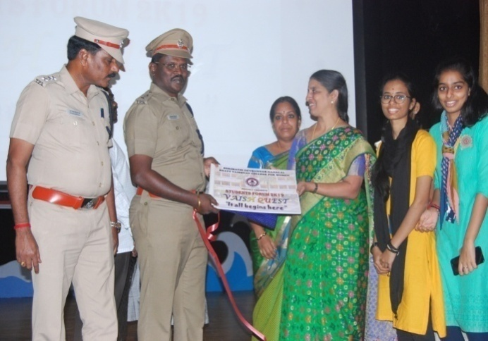
NATURAL GROOMING SESSION
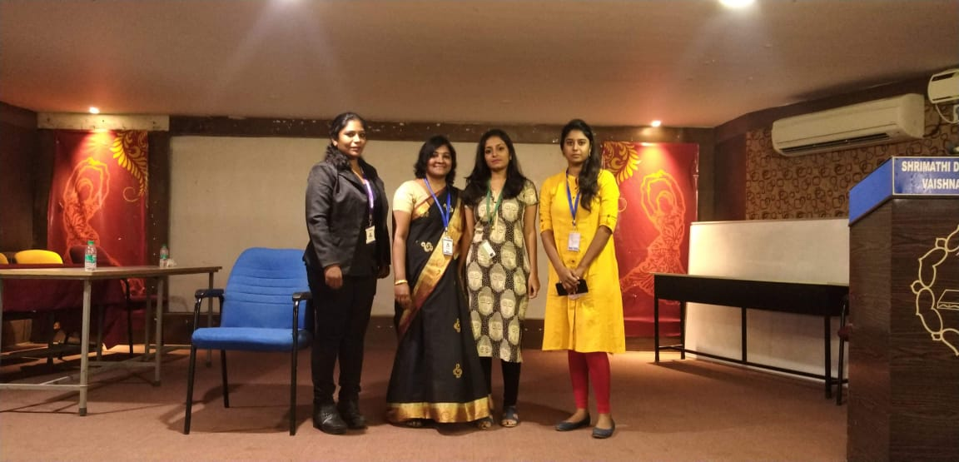
A grooming session conducted by Naturals, was held on 16th December 2019 for the final year students who enrolled themselves in the placement cells.
It was organised to help the students to face the interviews boldly. Ms. Sivagami Nagarajan, Centre Manager, explained about the various beauty care tips. Ms Krithika, Trainee Naturals, demonstrated how to apply makeup and enlightened the students about the importance of personal hygiene and the way of presenting oneself. Ms Sri Priya, Faculty Trainee, briefed about the different kinds of beauty products that can be used to groom one self. Students found it very useful and informative.
IMS INFORMATION SESSION
IMS conducted an Information Session for the students, which was held on 18th December 2019. IMS has been a pioneer in preparing students for various National and International entrance exams at various levels. Mr Jayadev, Lead Mentor from IMS, Chennai explained about the various training sessions for entrance exams like CAT, CET, GLAT, CMAT, GMAT at National and International levels. He also explained about the online test series which help the students to prepare for the exams. He encouraged the students to do Post Graduation Degree to enhance their professional career. The programme was an eye opening session for the students aspiring to crack competitive exams.
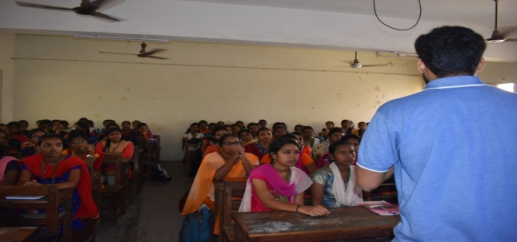
NEW YEAR CELEBRATION
New Year celebration was held on 19th December 2019. The college Principal Dr. R. Geetha and Vice Principal Dr. P. Beena graced the occasion. Students performed various entertaining programmes on the occasion of Christmas and New Year celebrations. Students and teachers shared their New Year resolutions with the audience. The students enjoyed the programmes thoroughly.
PONGAL CELEBRATIONS
Pongal Celebration was held on 11th January 2020 within the college premises. . Students from all the departments enthusiastically took part in preparing Pongal and showcasing the tradition of Tamil Nadu, thereby understanding the importance of Uzhavar Thirunaal. Students came in traditional attire and made Rangoli. They performed various Naatupura Kalaigal like Villupaatu and dance. Departments with best creativity won prizes for the same.

CONSTITUTION DAY
On commemorating ‘Constitution day’, an Essay Writing Competition was held on 6th December 2019. The topic for the competition was “Power of women in Indian constitution”. Students wrote essays in English and Tamil. A Quiz competition was also conducted based on Indian constitution on 20th January 2020 by the alumni of History Department. Prelims, executor and final rounds were conducted to select the winners for the quiz competition. Students took part in different competitions and won prizes.
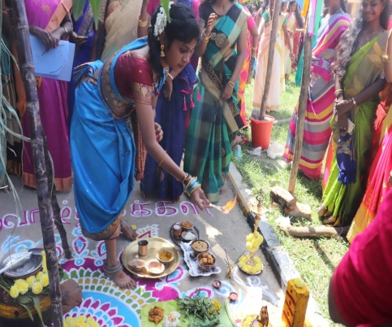
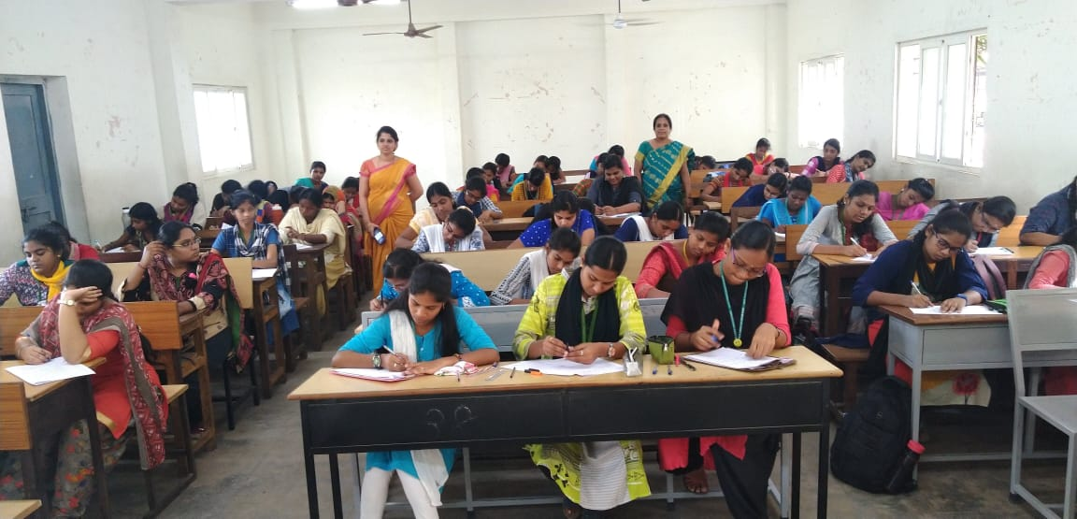
ELECTION AWARENESS PROGRAMME
An awareness programme was conducted to highlight the importance of Voting Rights. As a part of the awareness programme a Rangoli competition was conducted on 22nd January 2020 by the Union along with election commission. Deputy Tahsildhar and other Officials inspected the Rangoli made by the students related to the theme of election. Students enthusiastically participated and made informative and creative Rangoli. The best Rangoli were appreciated.

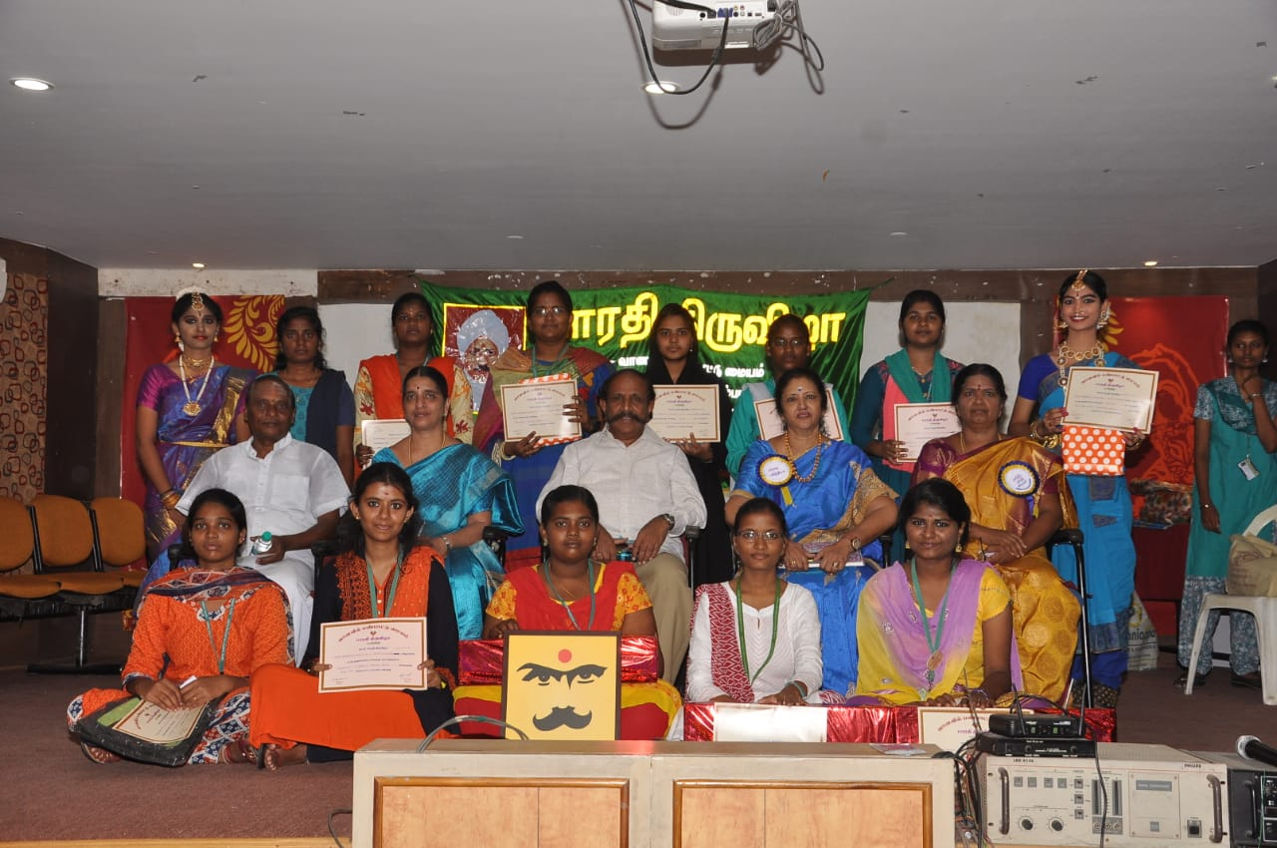
ghujp jkpo;g;Nguit
khzth;fsplk; Gije;Js;s gy;NtW jpwd;fis ntspf;nfhzUk; tpjj;jpy; ghujp jkpo;g; Nguitapd; rhh;ghf gy;NtW Nghl;bfs; brk;gh; jpq;fspy; elj;jg;gl;ld.

khzth;fspd; nrhy;yhw;wiy tsh;f;Fk; tpjj;jpy; Ngr;Rg;Nghl;bAk; ftpGidAk; Mw;wiy tsh;f;Fk; tpjj;jpy; ftpijg; Nghl;bAk; ek; jkpo;f;Fb kf;fspd; gz;ghl;Lg; ghjpTfshd nrhytil vd;W nrhy;yg;gLk; gonkhopapd; cz;ikg;nghUis mwpAk; nghUl;L njhpe;j gonkhopAk; jphpe;j nghUSk; vDk; nghUz;ikapy; FOg;Nghl;bAk; jkpo; ,yf;fpaj;ijAk; mjd; rpwg;GfisAk; mwpAk; tpjj;jpy; jkpNohL tpisahL vDk; tpdhb tpdh Nghl;bAk; elj;jg;gl;ld. gy;Jiw khztpaUk; Mh;tKld; gq;Nfw;Wg; ghpRfisj; jl;br; nrd;wdh;.

thdtpy; gz;ghl;L ikak; kw;Wk; =kjp Njt;Fd;th; ehdhyhy ;gl; kfsph; itztf; fy;Y}hp jkpo;j;Jiw ,ize;J elj;jpa ghlrhiyfs; NjhWk; ghujp Kof;fk;> ghujp jpUtpoh 2019 fy;Y}hp muq;fpy;. eilngw;wJ. ehs;: 06.12.2019> fhiy 9.00

rpwg;G tpUe;jpdh;fs;> jpU. Mh;. eluh[; (ips- Xa;T kapiy rl;lkd;w cWg;gpdh;)> fk;gd; fofk; ghy =dpthrd;> fiykhkzp. N\hgdh uNk\;> fy;Y}hp Kjy;tu;. , u. fPjh. jkpo;j;Jiwj;jiyth; Kidth;. jp. nre;jkpo;r;nry;tp. MfpNahh; gq;Nfw;wdh ;Ngr;R> ftpij> fl;Liu> ghl;L> eldk; MfpaNghl;bfspy; ghpRngw;wkhztpah;

ENCHANTE LITERARIA
INTERDEPARTMENTAL

“Enchanté Literaria”- Literary Association and Debate Club of Department of English conducted Inter-Departmental competitions on 3rd December 2019. Students from all the other departments took part actively in the events.
The events included T-shirt Painting, News Reading, Quiz, CookUp Your Story, Block and Tackle, Word Battle and Pictionary.
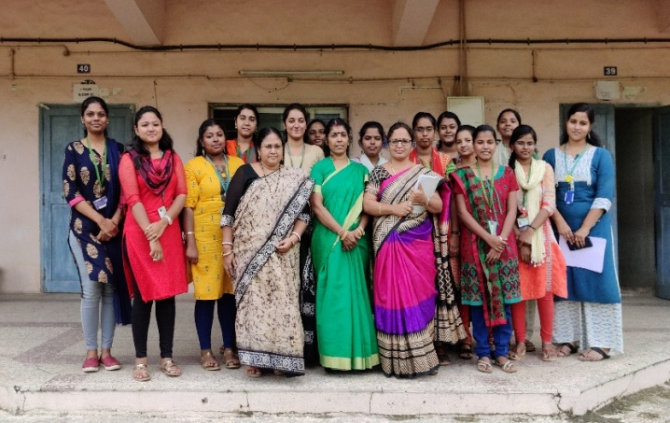
INTERCOLLEGIATE
The Inter-Collegiate competitions themed "Harry Potter" was conducted by Enchanté Literaria- Literary Association and Debate Club of Department of English on 16th December 2019. Students from various colleges took part in all the events. The events included Quiz, Cook Up Your Story, Block and Tackle, Treasure Hunt and Pictionary. The vivacious participation from the students made the event a grand success. The decorations done by the students of English Department were the talk of the week, in the campus. The students from Madras Christian College won the overall championship. The event came to an end with the valediction ceremony and the prizes were distributed by the judges of the respective events.
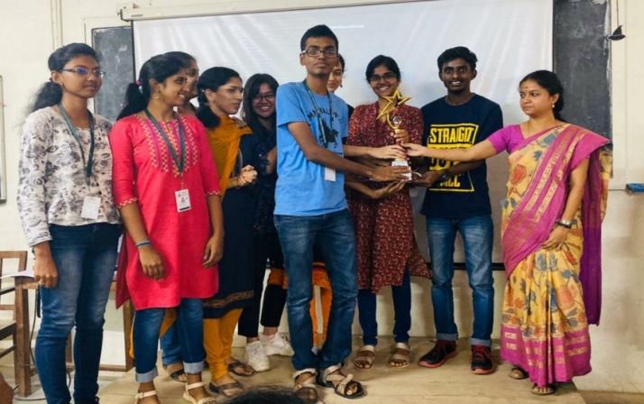
ROTARACT CLUB EVENTS
GROUP ROTARACT MEETING
The Group Rotaract Meeting was held on 17th December, 2019 at Loyola College.
Rotaract Club members of Shrimathi Devkunvar Nanalal Bhatt Vaishnav College for Women presented their projects in the district Group Rotaract Meeting and received the best project award for their project H₂O. Through their project the students helped the residents of Eashwari Nagar, Pallavaram by providing them 4000 litres of water.

JEEVODAYA CANCER HOSPITAL
Community service was done on 24th December, 2019 by the Rotaract members in Jeevodaya Cancer Hospital, Madavaram. The students distributed 19 kg of rice, biscuit packets, medicines and bread packets to the patients of Jeevodaya Cancer Hospital. This initiative was taken to inculcate compassion in the minds of the students for the society.
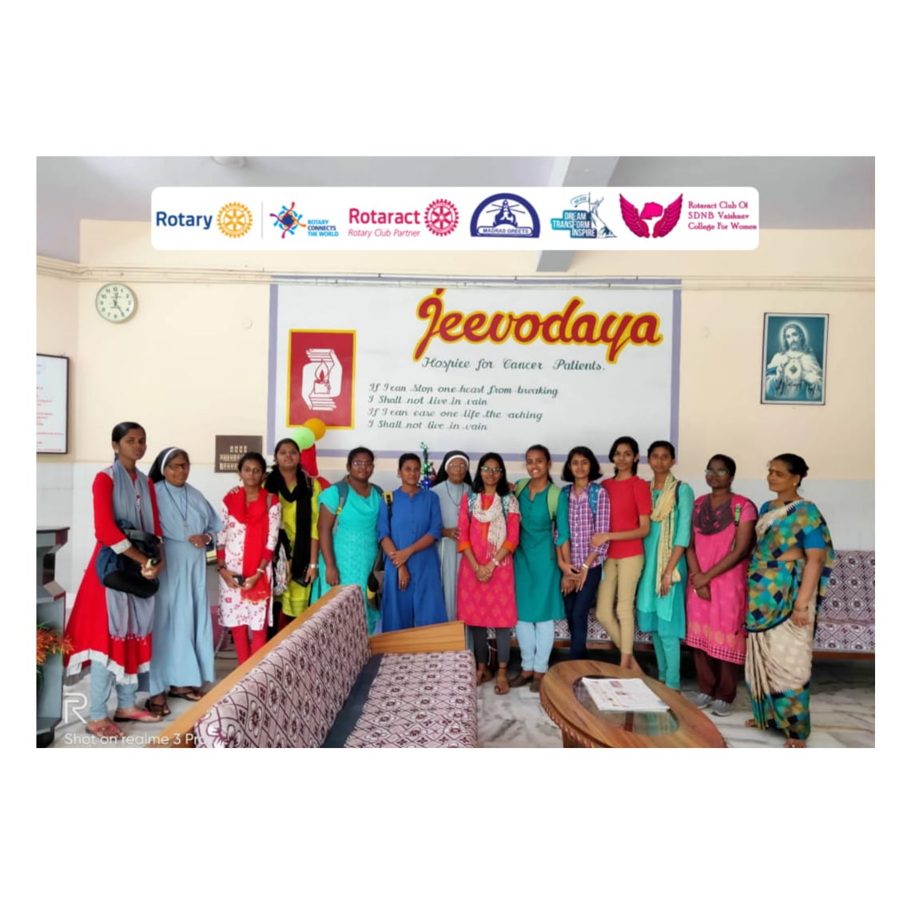
BRIGHTEN THE YEAR
The Rotaract members of Shrimathi Devkunvar Nanalal Bhatt Vaishnav College for Women, along with Rotaract Club of National College, RID 3000 in Pondicherry distributed food to the needy on the occasion of New Year on January 1st 2020 at Community International, Pondicherry. This was a step to celebrate New Year with the contentment of sharing and caring, for the society one lives in.
COMPASSIONATE PONGAL
The Rotaract members celebrated Pongal with the needy people of community. Service was done in a traditional way in the college campus on 11th January 2020. The students distributed clothes and food to the needy people.
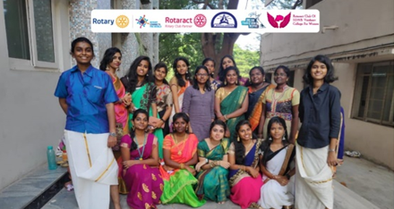
BLISS 2020
The Rotaract club of SDNB Vaishnav College for Women conducted, BLISS 2020 on 28th January 2020 in the college premises. This was a fund raising cultural programme in which participants from various colleges participated in various events.
The money collected through the event, was contributed for the educational expenses of mentally challenged children of Vasantham home. Many talented celebrities also supported our BLISS 2020. Rtn. Seshasai and Dr. Sudha made their presence as Chief Guests. The event was, no doubt a grand success.
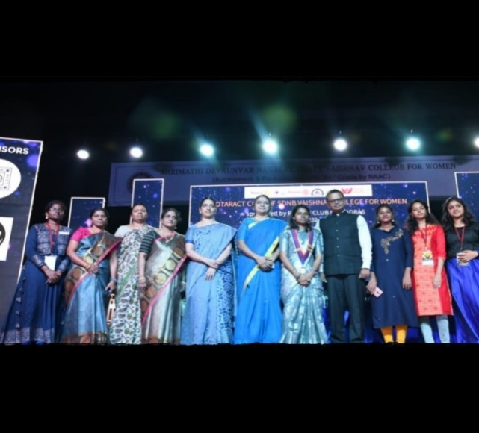
EDUCATIONAL TRIP TO KANCHIPURAM
The Department of Sanskrit organized a one day Educational Trip to the ‘Pandavaduta Perumal Temple’, ‘Ekambareswarar Temple’ and ‘Kanchi Kudil’ in Kanchipuram on 17th December 2019. The first year and second year students took part in the trip.
The students had an opportunity to visit the Pandavaduta Perumal Temple where they viewed the paintings and the inscriptions. The temple is known for its history of Lord Krishna visiting the Kauravas as a messenger for the Pandavas. In Ekambareswarar temple, the ancient mango tree holds a legendary story of how Lord Siva was named Ekambareswarar. Kanchi Kudil is a traditional house turned museum and is perfect to capture a glimpse of ancient Kanchipuram and its culture. A heritage tour to this enticing museum helped the students to know the traditional lifestyle of the town through its incredible exhibits.
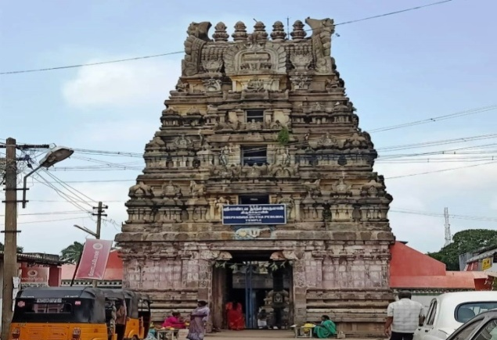
STATQUEST
The Statistics Association, “Stat Quest”, was conducted on 18th December 2019. Three interdepartmental events like Poster Presentation, Dumz and Quiz were conducted. The students from various department participated actively in all the competitions making the event a grand success.
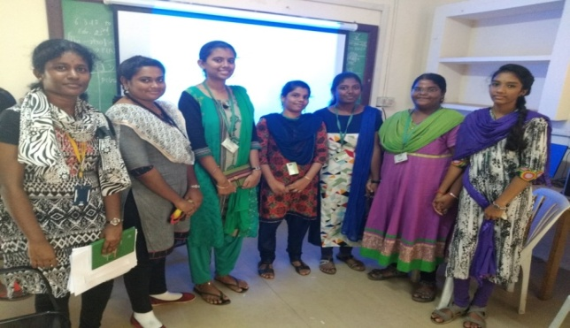
ONE DAY WORKSHOP ON AWARENESS ON GIRL CHILD TRAFFICKING
The Department of Hindi along with TAPAS Foundation, conducted a one day workshop on “Awareness on Girl Child Trafficking”. Mr.Vipul Singh Tapas, the Founder & President of TAPAS Foundation, who is also a popular street play artist and a noted TEDX speaker, was the Resource Person of this Workshop and he threw light on why and how girl children are kidnapped. He discussed in length about the crucial role of the society in this regard. He drew attention of the students on various APPLICATION SOFTWARES (apps) that are developed to prevent crime against Girls / Women. He also explained in detail about how these apps are to be installed and activated. This Workshop was an eye – opening session for our students.
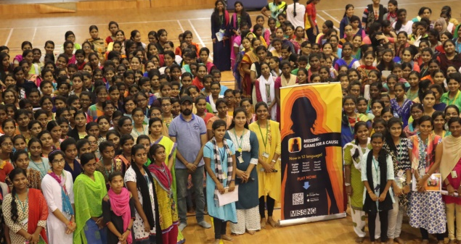
NSS UNIT EVENTS
IMPORTANCE OF LIFE - AWARENESS AND MEDICAL CAMP
A session regarding importance of life was conducted in which, Mr Khalid Ahamed, founder of Uravugal Trust, was the Resource Person. A free medical camp was conducted to the public in the college premises.
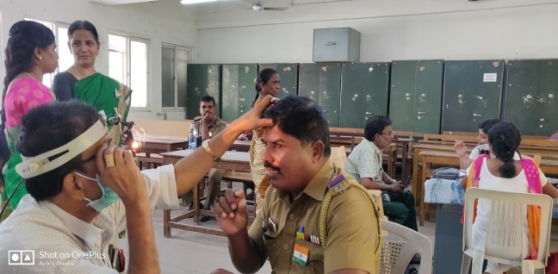
LEADERSHIP QUALITIES DEVELOPMENT
Young and aspiring people from Student’s Corridor spoke about leadership. Mr M. Manoj Kumar and R. Manish, the CEO and the Co-CEO of the student’s corridor were the Chief Guests. They talked about smart work and success in life. They also guided the volunteers to choose the right path. They advised the volunteers to flow like a river to reach success. Lastly, they interacted with the volunteers and the students were given guidance on how to achieve success.
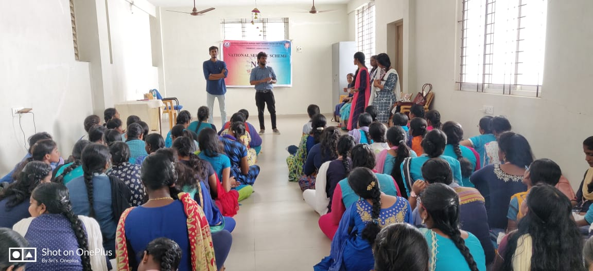
POSHITHAM TRUST
The volunteers from Poshitham Trust motivated the NSS volunteers with their inspirational speech and fun-filled interaction. They shared their inspiring story of their trust. They were the alumni of SDNB Vaishnav College NSS unit. The young volunteers learnt many things from them. The session was interactive. Mrs Subhashini, Assistant Professor, SDNB Vaishnav College also interacted with the volunteers about the importance of saving our environment.
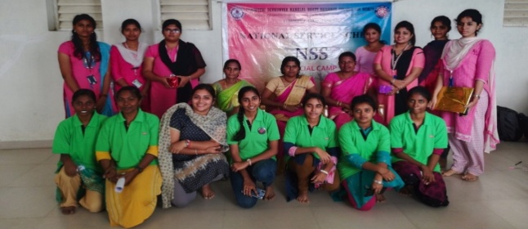
NSS CAMP
NSS unit organized a special camp of the academic year 2019-2020 in the village Nemilichery, Chrompet. The Chief Guest of this camp was Dr. G. Bhaskaran, NSS Coordinator, University of Madras. The guest was honoured by Dr S. Amutha. He inspired the volunteers with his speech. He emphasised the application of education through community service and mentioned about the advantages of the speciality of the on-going camp. The volunteers were inspired by his speech and promised to be the change in the society. The session came to an end with the vote of thanks.
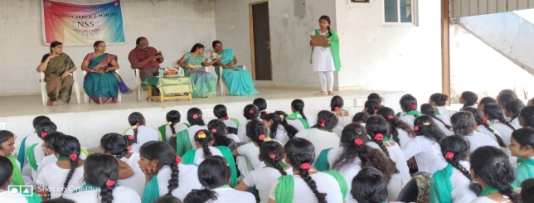
AWARENESS ON FOOD ADULTERATION
The NSS volunteers held a campaign in Nemilichery about the awareness on the food adulteration. They spoke about adulteration in food industries especially in fruits and dairy products. They further educated the people about the proper ways of consuming food. The volunteers also created awareness about the expiry date and the hazards of the adultery in the food industry. The people felt it as a friendly interaction rather than an awareness talk. The volunteers left an incredible change of ideas regarding food and the adulteration in the food industry among the people by the end of the campaign.
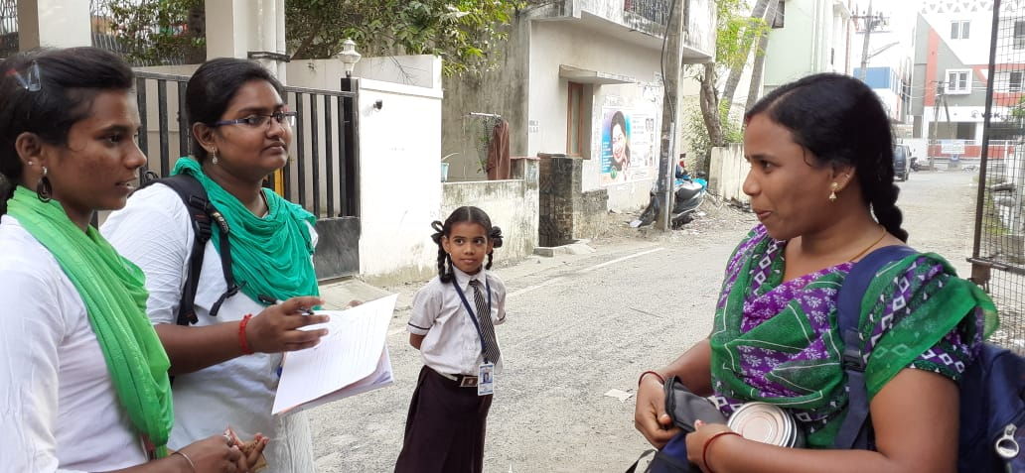
SCHOOL VISIT
The NSS volunteers visited Venketeshwara School in Chrompet, to create awareness among the school students, the NSS volunteers conducted many competitions. They also educated the children about cleanliness. They were able to quickly grasp the speech and responded with great interest. The students actively participated in the competition conducted by the volunteers. Prizes were distributed among the students who won the competition.
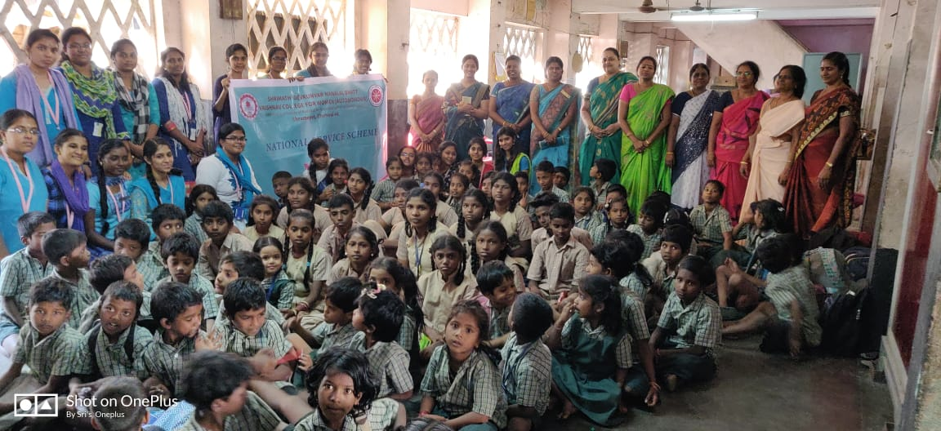
TECHNOLOGY AWARENESS
The NSS unit conducted a technology awareness programme in Nemilicherry, on 24th January 2020. The villagers were gathered and co-ordinated by the NSS volunteers in a smooth way. The technology awareness programme started with the session on basic usage and needs of ATM card. The NSS volunteers demonstrated and helped the peopleunderstand, how to use the ATM cardand the precautions against the fraudulent activities which might happen. This was followed by teaching the people to fill up bank challan. Each and every villager was provided with a bank challan and our NSS volunteers gave them the basics regarding their A/C name and number. They gave them guidelines about using smart phones and then, it was followed by feedback session, where they shared their experience.
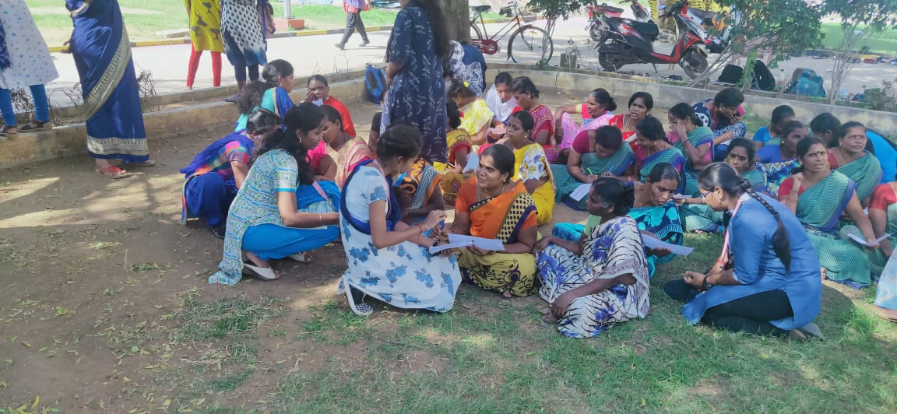
CHEMISTRY DEPARTMENT WORKSHOP
Department of Chemistry conducted One Day National Level workshop and Hands on Training on 3D printing in Chemistry on 21st January 2020 by Dr. Rahul Shivakumar, Director, ShivPrema Project Consultant, Chennai. Professors and Students from various Colleges participated in the event. The workshop attempted to impart the knowledge of chemical reaction and process carried out in 3D printing technology. Students had a chance to see how the 3D printing works. E-Certificate for taking part in the workshop was provided to all the students.
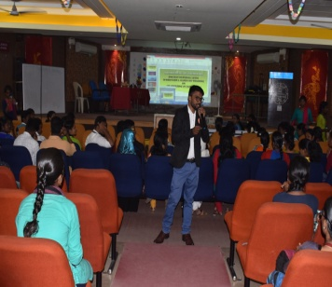
MATHS WORKSHOP
The Department of Mathematics organized a Workshop - “A Gentle Introduction to Scilab towards Research” on December 10, 2019. The Chief Guest was Dr. S. Athithan, Assistant Professor of SRM Institute of Science and Technology. The Workshop consisted of plenary sessions with an introduction of Scilab and concurrent sessions were carried with practical knowledge of finding solutions to Matrix operations, Differential Equations and Numerical problems. The students were also encouraged to take part in interactive sessions.
PHYSICA-2019
The PG Department of Physics held their inter-departmental Competition –PHYSICA on December 13, 2019. They hosted the following events PHYSICS QUIZ, POTPOURRI and E- CRAFT in which many students of various departments participated energetically.
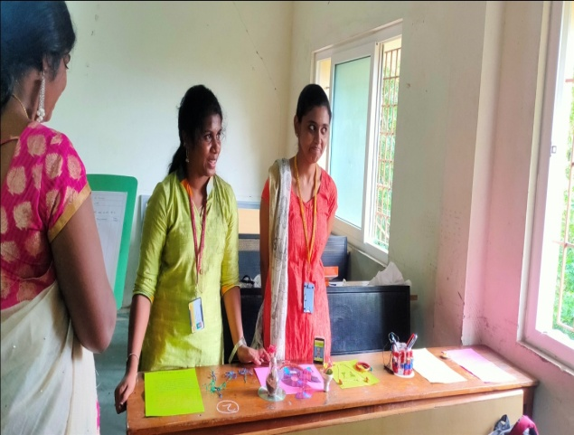
MA HRM GUEST LECTURE
The Department invited Ms.Jayanthi Kannan to deliver a Guest Lecture on the topic “Which is important? Creativity or Efficiency?” on December 12, 2019. The Lecture inspired the audience who were members of the Madras Management Association.
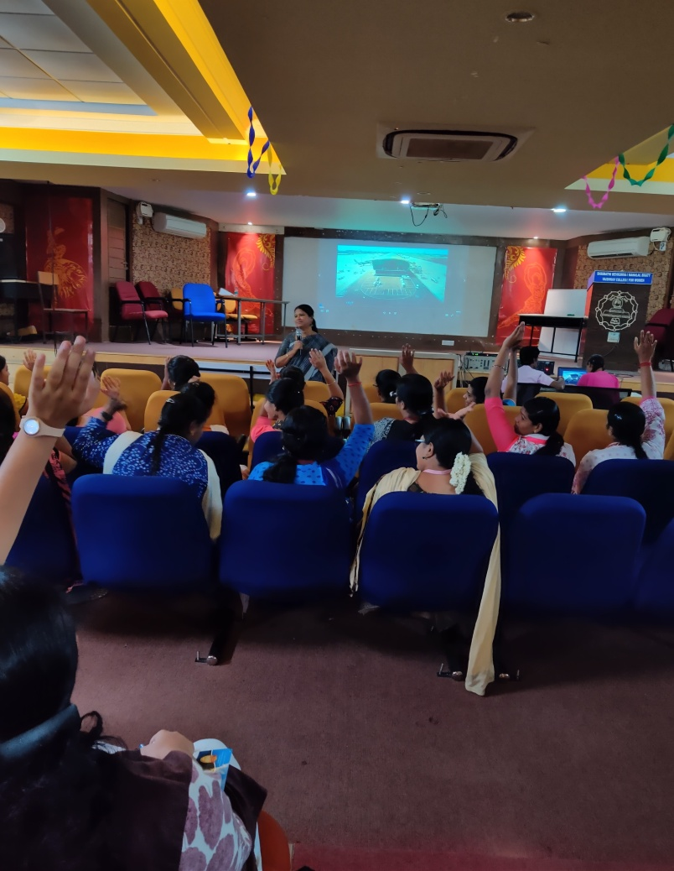
ENGLISH LITERARY ASSOCIATION COMPETITIONS
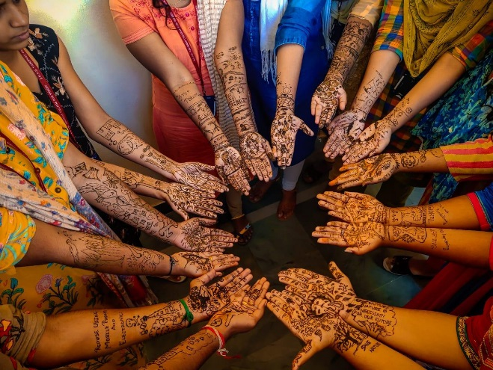
On December 17, 2019, Literary Association of PG Department of English conducted Inter-Departmental competitions to provide a platform for the postgraduate students across various disciplines to explore and exhibit their cognitive and creative abilities and skills. The events were Collage Making and Mehendi Art. Both the events drew enthusiastic and artistic participants who created insightful collages and Mehendi Art.
CHEMSTROM
The PG Department of Chemistry conducted their Inter-Departmental competitions CHEMSTROM on December 18, 2019. They organized events like Quiz, Cook Without Fire and Poster Making (SCIENCE IN EVERYDAY LIFE). Students from various departments participated with zeal and enthusiasm.
FDP ON FINANCIAL MODELLLING
The Department of B.Com (A&F) had organised a Faculty Development Programme for Commerce Staff on Financial Modelling conducted by IMS Pro School during 11th, 13th and 16th of December, 2019. The sessions were very enriching to the teachers.
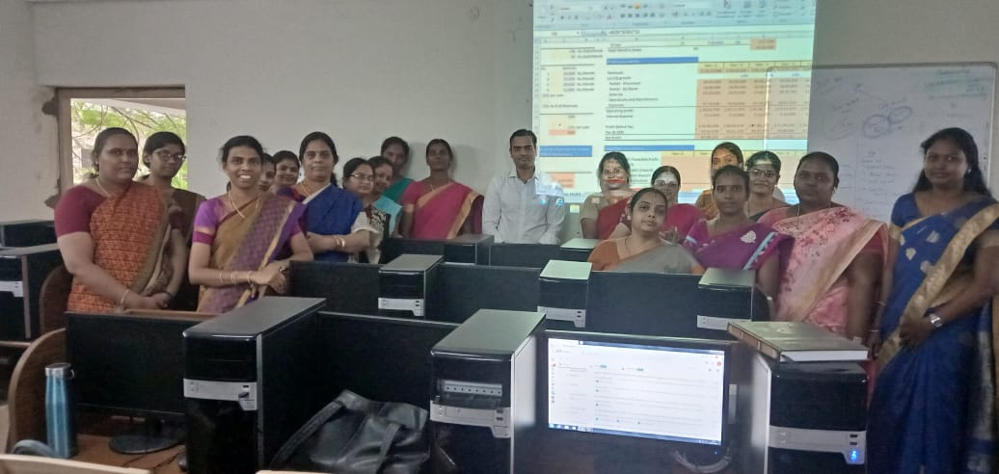

BIO-STATISTICA 2K20
The Statistics Association’s Inter-Departmental activity was held on December 19, 2019 with its distinguished name “Bio-Statistica2k20”. The theme of this activity was to enhance the statistical knowledge of the students from various disciplines (other than Statistics) of S.D.N.B. Vaishnav College For Women.
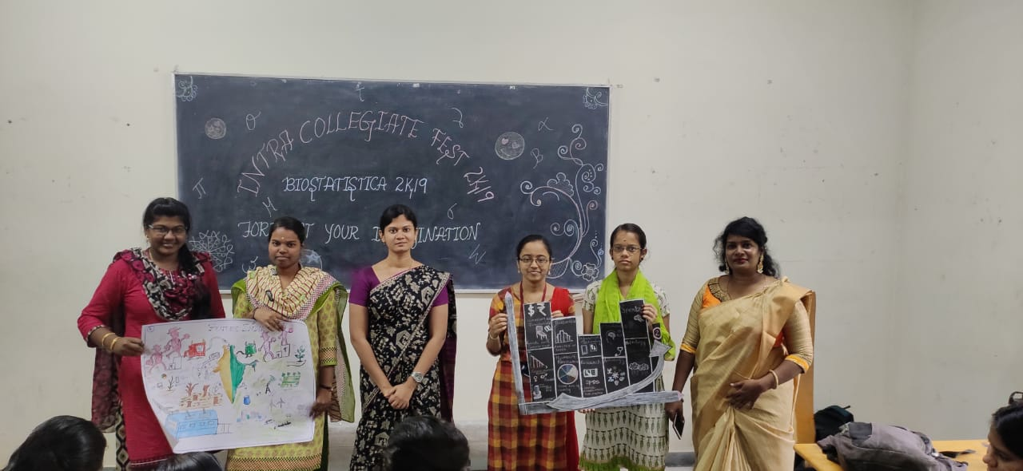

MATHRIOR 2020
Inter Collegiate Fest - MATHRIOR 2020 was conducted by the Department of Mathematics on January 28th, 2020. Nearly 80 students from various colleges participated in different events conducted by the Department of Mathematics. Mathesitlus(Paper Presentation), Cut Copy Paste(Collage), Meme Mathers (Meme Creation), Mathlexia (Quiz), Math Frolic (Potpourri) were conducted. Dr. K. Ezhilarasi Stanley, Associate Professor & Head, Ethiraj College for Women, Dr. Fernandes Jayashree, Dean Academics, Associate Professor & Head, M.O.P. Vaishnav College, Mrs. G. Devi, Assistant Professor, Department of Mathematics, Sri Sairam Engineering College, Mrs. Linda Joel, Assistant Professor, Department of Mathematics, SRM Institute of Science and Technology, were all invited as Judges to the competitions.
SEMINAR ON THE ROLE OF MICROORGANISMS IN PREVENTION OF DISEASE
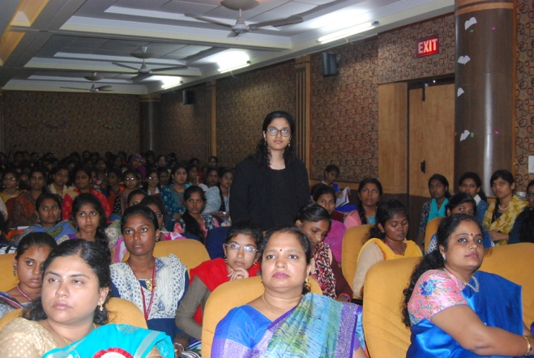
“Let thy food be thy medicine and medicine be thy food” famous quotes by Hippocrates that emphasize the importance of nutrition to prevent diseases. Increased awareness on the importance of lifestyle modification for disease prevention, we are now facing a renaissance of nutrition.
With this need in mind the Department of Nutrition Food Service Management and Dietetics had organized an INVITED TALK on, “Role of Microorganisms in Prevention of Disease” on January 28th, 2020. The Chief Guest for the event was Ms. Maria Jenita Peter, Research Consultant and Visiting Faculty, Anna University. The talk emphasized the benefits of microbes and recent research studies on quorum sensing, food bio preservation and role of microbes in preventing cancer of Gastro-intestinal tract. The highlight of the session was on the need of Prebiotics and Probiotics in enhancing the Gut health.
LATEST AMENDMENTS IN COMPANIES ACT

On 11th December 2019, the Research Department of Commerce in collaboration with University of Madras organised a Faculty Workshop on “Latest Amendments in Companies Act” for Commerce faculty members, working in affiliated colleges of University of Madras, C. S Desihan Balaji was the Resource Person. Nearly, 70 Commerce faculties working in affiliated colleges of University of Madras, attended the workshop.
COMFEST 2019-20 “AMAZE”
VAISH COMFEST 2019-20 “AMAZE” – the Annual Commerce fest was organised on January 9, 2020. It was inaugurated by Shri. Ragav Devanathan, Managing Director of an IT company, Chennai. Dr. D. T. Roshini, Director, GETWHAT, Chennai was the special Guest of the occasion.
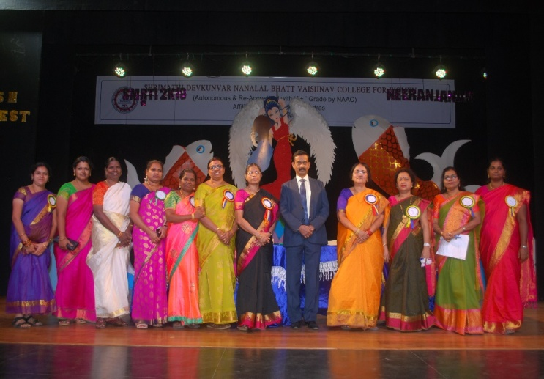
Students from 30 colleges participated in events such as Adzap, Channel Surfing, Business Quiz, Poster Designing and 60 Seconds to Fame.
Dr. S. Gurusamy, Professor and Head Department of Commerce, University of Madras, delivered the valedictory address and distributed the prizes. The overall trophy was won by Ethiraj College for Women.
DEPARTMENT OF ENGLISH – INTERNATIONAL CONFERENCE
Shrimathi Devkunvar Nanalal Bhatt Vaishnav College for Women organised an INTERNATIONAL CONFERENCE ON REVISITING ENGLISH LANGUAGE AND LITERATURE IN A MULTICULTURAL MILIEU 2020 on 22nd January 2020. The Chief Guest Dr. R. Ravanan, Regional Joint Director of Collegiate Education, Chennai motivated the students with his inspiring life experiences. The keynote speech was given by Dr. Mahendran Manim, Sultan Idris University, Malaysia, spoke on application of Bloom’s Taxonomy for evaluating students living in the era of multiculturalism. In the digital age teachers should be updated and how technology can act as a facilitator to channelize the millennial generation in the right manner. Dr. Widyastuti Purbani, Yokyakarta State University highlighted the class struggle that is still prevalent in the multicultural modern world.

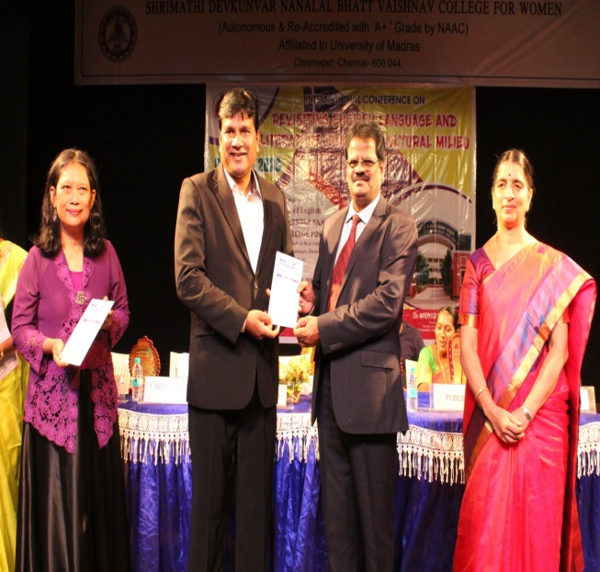
She insisted on inculcating inclusivism in young minds and unity in diversity be given due consideration. Dr. Shyamkiran Kaur, Dr. B R Ambedkar National Institute of Technology, Punjab, delivered the valedictory address on issues in Indian fiction writings of the multicultural world. More than 150 participants from different parts of the country attended the conference. Participants from Sri Lanka and Saudi Arabia also presented their papers. The conference papers debated and discussed the conflicts and coexistence arising out of multiculturalism in the world which is reflected in literature.

EDITOR IN CHIEF:
Dr. R. Geetha, Principal
FACULTY EDITORS:
Ms. G. Thilakavathy, Assistant Professor, Department of English
Mrs. L. Divyabharathi, Assistant Professor,
Department of English
Mrs.S. Susan, Assistant Professor, Department of English
STUDENT EDITORS:
Priya Ayilam Chidambaran, III B.A. English
D.Pavithra, III B.Sc. Statistics
K. HemaSuriya, II B.Sc. Physics
Bhargavi, I M.A. English
Farzana Begum K, I M.A. English

